5 MARLA SMART VILLAS 3 BEDS

PRICE

RS. 94,80,000,000 *

Overseas Block I

Executive Block I

* Including Development Charges
* See Terms & Conditions

5 Marla's Villa, located in Capital Smart City, outstanding villas with full height windows that promote natural lighting and great views of the beautiful picturesque surroundings. The villas are in closer proximity to the outer edges, landscaped parks and fresh green meadows. The interior decors of the Villas are tailor-made for families in mind and can be used as 1 or 2 family units as a matter of personal choice.
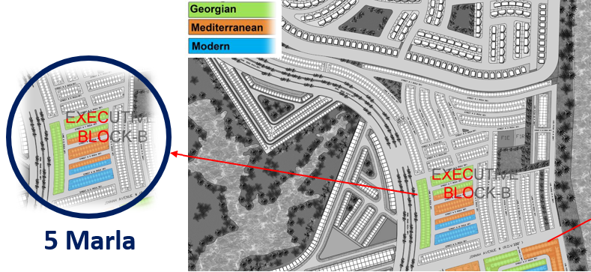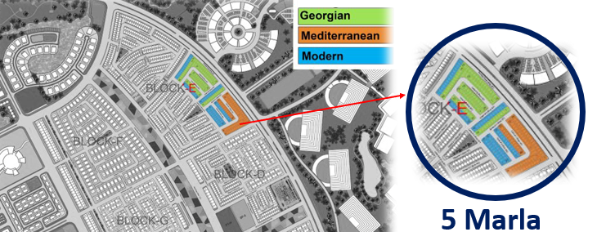
- CONTEMPORARY
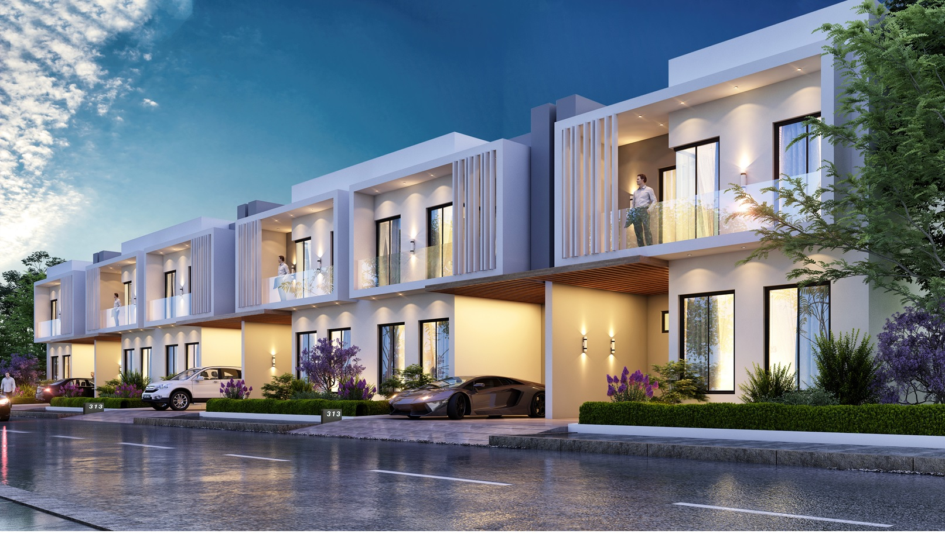

Art Gallery

FLOOR PLANS

Area Specification
Plot Area: 1125 S.ft.
Plot Size: 25’ X 45’
Total Covered Area: 1703 S.ft.
Ground Floor Covered Area: 946 S.ft.
First Floor Covered Area: 757 S.ft.

Ground Floor
Bed Rooms | 1
Dress & Bath | Yes
Living Room | Yes
Kitchen | Yes
Laundry | Yes
Car Porch | Yes
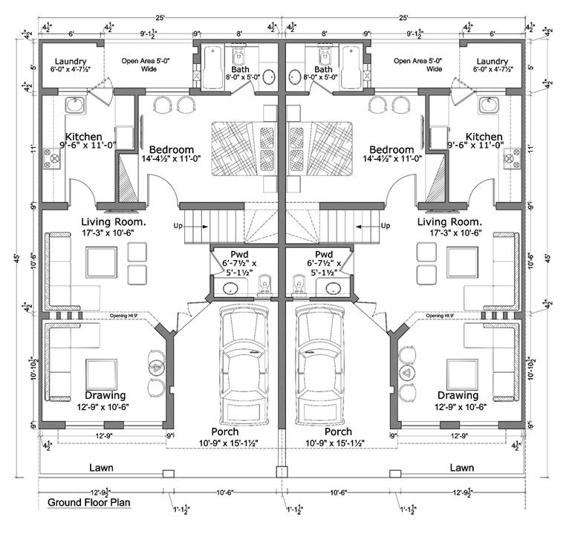

First Floor
Bed Rooms | 2
Living Room | Yes
Kitchenette | Yes
Dress & Bath | Yes
Terrace | Yes
Bath | Yes
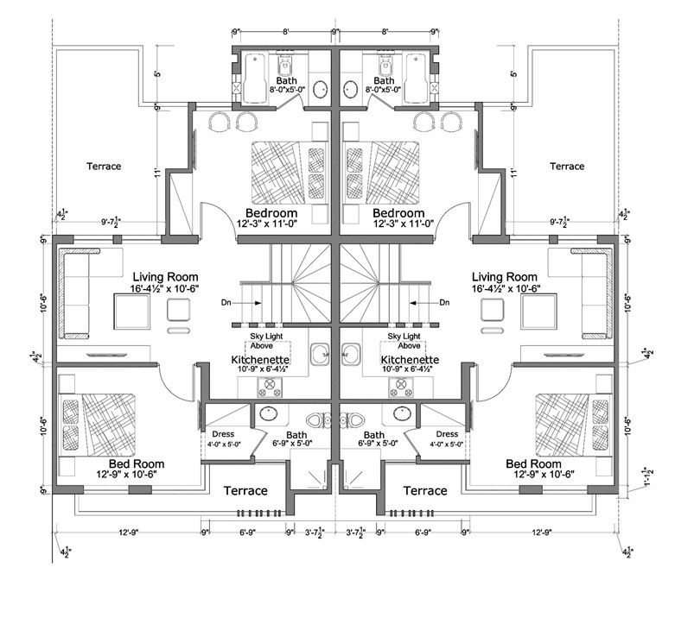

CIVIL WORKS AND MEP FEATURES
- Earthquake-resistant Structure
- Large Size Concrete Water Tanks
- Underground Septic Tank
- RCC Concrete Slab Structure
- PPRC Pipes (Master Brand or Equivalent)
- UPVC Pipes (Accufit Brand or Equivalent)
- GI Piping (IIL-Medium or Equivalent)
- Electrical Conduits (Popular or Equivalent)
- Electrical Wiring (Newage Cables or Equivalent)
- Lighting (SMD Lighting)
- Minimal Circuit Breakers (Schneider or Equivalent)
- AC Copper Piping (Dawlance 22 Gauge)
- Double DPC System
- Anti-Damp Treatment
- Anti-Termite Treatment
* The list of above material is to classify the quality of products.

FINISHING FEATURES
- Imported Porcelain Floor Tiles
- Imported Bath Tiles
- Imported Kitchens & Wardrobes
- Premium Imported Granite (Kitchen Counter Top)
- Premium Imported Granite (Stairs/Steps Finish)
- Imported Wood Veneer Doors
- Imported Granite/Marble Window Sills
- Indoor Paint (ICI Plastic Emulsion or Equivalent)
- Outdoor Paint (ICI Weather Shield or Rock Wall)
- Powder Coated Prime Aluminum or Equivalent Windows
- 8 MM Tempered Glass Shower Enclosures
- Steel Main Gate 14 gauge
- Imported Brand Sanitary Wares
- Imported Brand Sanitary Fittings
- Electrical Switches (Clipsal Brand or Equivalent)
- Stainless Steel Stairs Railing
- Gas/Electric Operated Geyser's
- Fans (Pak Fan or Equivalent)
- Imported SMD/COB Down Lights

Villas Prime Location Charges
- 5% Extra: Facing Park
- 5% Extra: Boulevard (41' & Above)
- 7.5 % Extra: Corner
- Other choice will be charged 2.5% extra except corner

